Array
Name : Sreya Sudheeran
Mis : 612303175
Div : 2
Batch : S4

1. Write a program that calculates the sum of squares of the elements of an integer array
of size 10.

Ans:
#include <stdio.h>
#define SIZE 10

int main(){
int arr[SIZE];
int ans = 0;
for (int i = 0; i < 10; i++){
scanf("%d",&arr[i]);
}
for (int i = 0; i < 10; i++){
ans=ans+(arr[i]*arr[i]); /*updates ans variable for the desired result*/
}
printf("%d\n",ans);
}
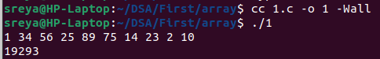
Output

2. Display array elements in reverse. ie from last to first.
Ans:
#include <stdio.h>
#define SIZE 10

int main(){
int arr[SIZE];
for (int i = 0; i < 10; i++){
scanf("%d",&arr[i]); /*takes input from the user */
}
for (int i = 9; i > -1; i--){
printf("%d| ",arr[i]); /*prints the array in reverse order*/
}
printf("\n");
return 0;
}
Output

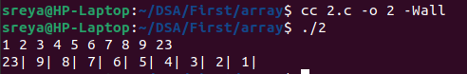

3. Write a program to search for an element accepted from user in an array of floating-
point values of size 50. Display the index if element is found else display message
Not Found.
Ans:
#include <stdio.h>
#include <stdlib.h>
#include <time.h>

int main(){
float arr[50];
float val;
srand(time(NULL));
for (int i = 0; i < 50; i++) {
int val = rand() % 100;
arr[i] = (float) val; /* Generate random array elements between 0 and 99 */
}
scanf("%f",&val);
for (int i = 0 ;i < 50; i++){
if (arr[i] == val){ /* Checks if the value matches the array element */
printf("Element found at index %d\n",i);
return 0;
}
else{
continue;
}
}
printf("Not Found");
return 0;
}

Output
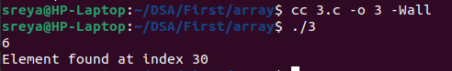

4. Display elements of array in triangle pattern. Use formatting to get a uniform display
Ans:
#include <stdio.h>

int main(){
int a [] ={60,700,80,900,10};
for(int i = 0; i <5 ;i++){
for(int j= 0; j <= i; j++){
printf("%d ",a[j]);
}
printf("\n");
}
return 0;
}

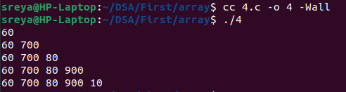
Output

5. You know size of integer array. Can you find number of elements in it? How?
Ans: Yes, you can find the number of elements in an integer array by dividing the total size of the array by the size of one element.
Formula : sizeof(array) / sizeof(array[0])

6. Write C program to shift all elements of an array by n locations to right or left in
circular fashion. Take all inputs from user.

Ans:
#include <stdio.h>
#define SIZE 10
int main(){
int val;
int circle;
printf("Enter length of Array : ");
scanf("%d",&val);
int arr[SIZE];
int arrl[SIZE];
int arrn[SIZE];
printf("Enter Array :");
for(int i = 0; i < val; i++){
scanf("%d",&arr[i]);
}
for(int i = 0; i < val; i++){
arrl[i] = arr[i];
}
printf("Enter the value to be shifted : ");
scanf("%d",&circle);
for(int j = 0; j < circle; j++){ /*to right */
for(int k = 0; k < val-1 ; k++){
arrn[k+1] = arr[k];
}
arrn[0] = arr[val-1];
for(int i = 0; i < val; i++){
arr[i]=arrn[i];
}
}

for(int i = 0; i < val; i++){
printf("%d",arr[i]);
}
printf("\n");
for(int j = 0; j < circle; j++){ /*to left */
for(int k = 1; k < val ; k++){
arrn[k-1] = arrl[k];
}
arrn[val-1] = arrl[0];
for(int i = 0; i < val; i++){
arrl[i]=arrn[i];
}
}

for(int i = 0; i < val; i++){
printf("%d",arrl[i]);
}
printf("\n");
return 0;
}

Output

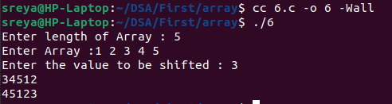

7. Delete all duplicate elements from an array retaining the first occurrence. Note:
Array elements cannot be deleted. shift and replace can be done.

Ans:
#include <stdio.h>
#define SIZE 10

int main(){
int val;
int arr[SIZE];
printf("Enter length of Array :"); /*inputs the length of the array */
scanf("%d",&val);
printf("Enter Array :");
for(int i = 0; i < val; i++){ /*inputs the element of the array */
scanf("%d",&arr[i]);
}
for(int i = 0; i < val; i++){
for(int j = i+1; j < val ; j++){ /*removes duplicate elements*/
if(arr[i] == arr[j]){
arr[j] = arr[j+1];
j--;
val--;
}
}

}
for(int i = 0; i < val; i++){
printf("%d| ", arr[i]);
}
printf("\n");
return 0;
}

Output

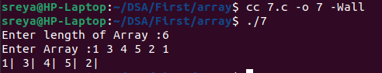

8. #include<stdio.h>
#include<stdlib.h>
int main() {
int c, n;
printf("Ten random numbers in [1,100]\n");
for (c = 1; c <= 10; c++) {
n = rand() % 100 + 1;
printf("%d\n", n);
}
return 0;
}
Study the above code. Read more about rand() function.
Initialize array of integers with values ranging 50 – 100 both inclusive and display
the contents.
Ans:
#include <stdio.h>
#include <stdlib.h>
#include <time.h>
#define SIZE 10

int main(){
srand(time(NULL));
int c = 10;
int arr[SIZE];
for(int i = 0; i < c; i++){
arr[i] = rand() % 50+ 50; /*generate numbers between 50 and 100*/
}
for(int i = 0; i < c; i++){
printf("%d ",arr[i]);
}
printf("\n");
return 0;
}

Output

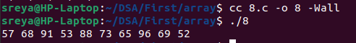

9. Take 20 integer inputs from user and print the following:
number of positive numbers
number of negative numbers
number of odd numbers
number of even numbers
number of 0.

Ans:
#include <stdio.h>
#define SIZE 20

int main() {
int arr[SIZE];
int pos = 0;
int neg = 0;
int even = 0;
int odd = 0;
int zero = 0;
for(int i = 0; i < 20; i++) {
scanf("%d", &arr[i]);
}

for(int i = 0; i < SIZE; i++) {
if(arr[i] == 0) {
zero++;
}
else if(arr[i] > 0) {
pos++;
}
else {
neg++;
}

/* Check for even and odd numbers*/
if(arr[i] != 0) {
if(arr[i] % 2 == 0) {
even++;
}
else {
odd++;
}
}
}
/*Displays the result*/
printf("Zeroes: %d\n", zero);
printf("Positive numbers: %d\n", pos);
printf("Negative numbers: %d\n", neg);
printf("Even numbers: %d\n", even);
printf("Odd numbers: %d\n", odd);

return 0;
}

Output

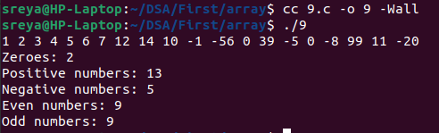

10. Write a program to check if elements of an array are same or not it read from front or
back. E.g.-
2 3 15 15 3 2

Ans:
#include <stdio.h>
#define SIZE 10

int main() {
int val;
int arr[SIZE];
int arrn[SIZE];

printf("Enter length of Array: ");
scanf("%d", &val);

printf("Enter Array: ");
for(int i = 0; i < val; i++) {
scanf("%d", &arr[i]);
}

/* Create a reversed array */
for(int i = 0, j = val - 1; i < val; i++, j--) {
arrn[i] = arr[j];
}
int palindrome = 1; /* Assume it's a palindrome initially */
for(int i = 0; i < val; i++) {
if(arr[i] != arrn[i]) {
palindrome = 0; /*Not a palindrome */
break;
}
}

if(palindrome) {
printf("Palindrome.\n");
}
else {
printf("Not a palindrome.\n");
}

return 0;
}

Output

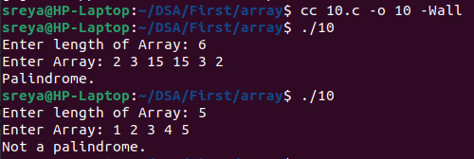

11. Reverse elements of array without using additional array.
Eg
input array – {10,45,3216,88}
should change to {88,16,32,45,10}

Ans:
#include <stdio.h>
#define SIZE 10

int main(){
int arr[SIZE];
int val;
int var;
scanf("%d",&val);
for (int i = 0; i < val; i ++){
scanf("%d",&arr[i]);
}
for (int i = 0, j = val - 1; i < j ; i ++ , j--){
var = arr[i]; /*swaping the contents */
arr[i] = arr[j];
arr[j] = var;
}
for(int i = 0; i < val; i++){
printf("%d ", arr[i]);
}
printf("\n");
}

Output
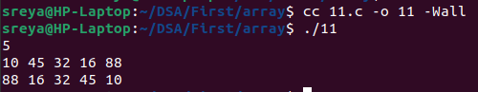

12 .C program to find nearest lesser and greater element in an array.

Ans:
#include <stdio.h>
#include <limits.h>
#define SIZE 10

int main() {
int arr[SIZE];
int len;
int value;
int great = INT_MAX; /* Initialize to largest possible value */
int greatv = -1;
int less = INT_MAX; /* Initialize to the largest possible value */
int lessv = -1;
printf("Enter the value to compare: ");
scanf("%d", &value);
printf("Enter the number of elements in the array: ");
scanf("%d", &len);
if (len > SIZE) { /*Handles overflow*/
printf("Array size exceeds maximum allowed size\n");
return 0;
}
printf("Enter the elements of the array:\n");
for (int i = 0; i < len; i++) {
scanf("%d", &arr[i]);
}
for (int i = 0; i < len; i++) { /* Find the nearest greater and lesser elements*/
int diff = arr[i] - value;
if (diff > 0) {
if (diff < great) {
great = diff;
greatv = arr[i];
}
}
else if (diff < 0) {
int absDiff = -diff;
if (absDiff < less) {
less = absDiff;
lessv = arr[i];
}
}
}
if (greatv != -1) {
printf("%d\n", greatv);
}
else {
printf("No greater element found.\n");
}

if (lessv != -1) {
printf("%d\n", lessv);
}
else {
printf("No lesser element found.\n");
}
return 0;
}

Output

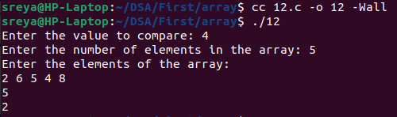

13. You have 2 arrays of size 5 each having elements in sorted order. Create a new array
of 10 having elements of the both the arrays in sorted order.
Ans:
#include <stdio.h>
#define SIZE 10
#define SIZE_1 5
#define SIZE_2 5

int main(){
int C[SIZE], A[SIZE_1], B[SIZE_2];
int lena, lenb;
printf("arr1 ");
scanf("%d", &lena);
for (int i = 0; i < lena; i ++){
scanf("%d", &A[i]);
}
printf("arr2 ");
scanf("%d", &lenb);
for (int i = 0; i < lenb; i ++){
scanf("%d", &B[i]);
}
int len = lena + lenb;
int i = 0, j = 0, k = 0;
while(k < len){ /*sorts the arrays */
if(A[i] > B[j]){
C[k] = B[j];
j++;
k++;
}
else if(A[i] < B[j]){
C[k] = A[i];
i++;
k++;
}
else{
C[k] = A[i];
i++;
k++;
}
}
for (int i = 0; i < len; i ++){
printf("%d ",C[i]);
}
printf("\n");
return 0;
}
Output
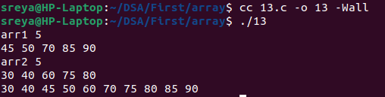

14. Populate an array of size 100 with values generated randomly between 1 to 1000.
Copy all the numbers divisible by 8 or 15 to a new array. Display both arrays

Ans: #include <stdio.h>
#include <stdlib.h>
#include <time.h>
#define SIZE 100

int Divisible_by_8_or_15 (int num) {
return (num % 8 == 0) || (num % 15 == 0);
}

int main() {
int arr[SIZE];
int ans[SIZE];
srand(time(NULL));
for (int i = 0; i < SIZE; i++) {
arr[i] = rand() % 1000 + 1; /*generate random array*/
}
int len = 0;
for (int i = 0; i < SIZE; i++) {
if (Divisible_by_8_or_15(arr[i])) {
ans[len] = arr[i];
len++;
}
}
printf("Array:\n");
for (int i = 0; i < SIZE; i++) {
printf("%d ", arr[i]);
}
printf("\n");
printf("Numbers divisible by 8 or 15:\n");
for (int i = 0; i < len; i++) {
printf("%d ", ans[i]);
}
printf("\n");
return 0;
}
Output

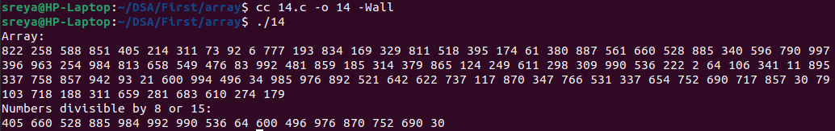

15. Write code to find second largest element in a 1D Array.
Ans: #include <stdio.h>
#define SIZE 10

int main(){
int arr[SIZE];
int val;
int max = 0;
int max2 = 0;
scanf("%d", &val);
if(val == 1 || val == 0){
printf("no");
return 0;
}
for (int i = 0; i < val; i ++){
scanf("%d", &arr[i]); /*inputs the array */
}
for (int i = 0; i < val ; i ++){
if(arr[i] > max){ /*compares with max to find the second max */
max2 = max;
max = arr[i];
}
}
printf("%d", max2);
}

Output

